How to design software architectures

# Software Architecture

## Subsystem-based architecture

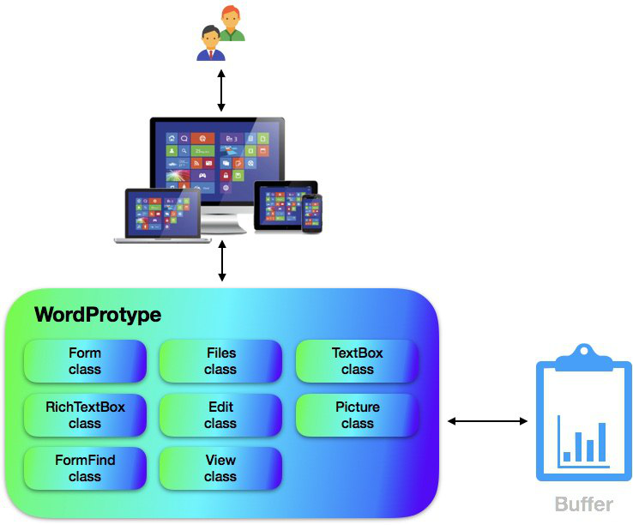

## Subsystem description

* **Form** is a **class** that constitutes the overall **UI** displayed on the actual screen.
* **Files** consists functions related to file: New, Open, Save.
* **TextBox** is a **class** for receiving input when searching for a character or string.
* The **RichTextBox** is a **class** that forms the input space for typing, which is the most important element in **WordProType**.
* **Edit** is a **class** for editing characters such as copying and pasting.
* **Picture** is a **class** for inserting picture through file dialog.
* **FormFind** **Class** for finding or changing matching characters in input characters.
* **View** is a class for enlarging or reducing the **WordProType** screen.

# Software Architecture

## Subsystem-based architecture

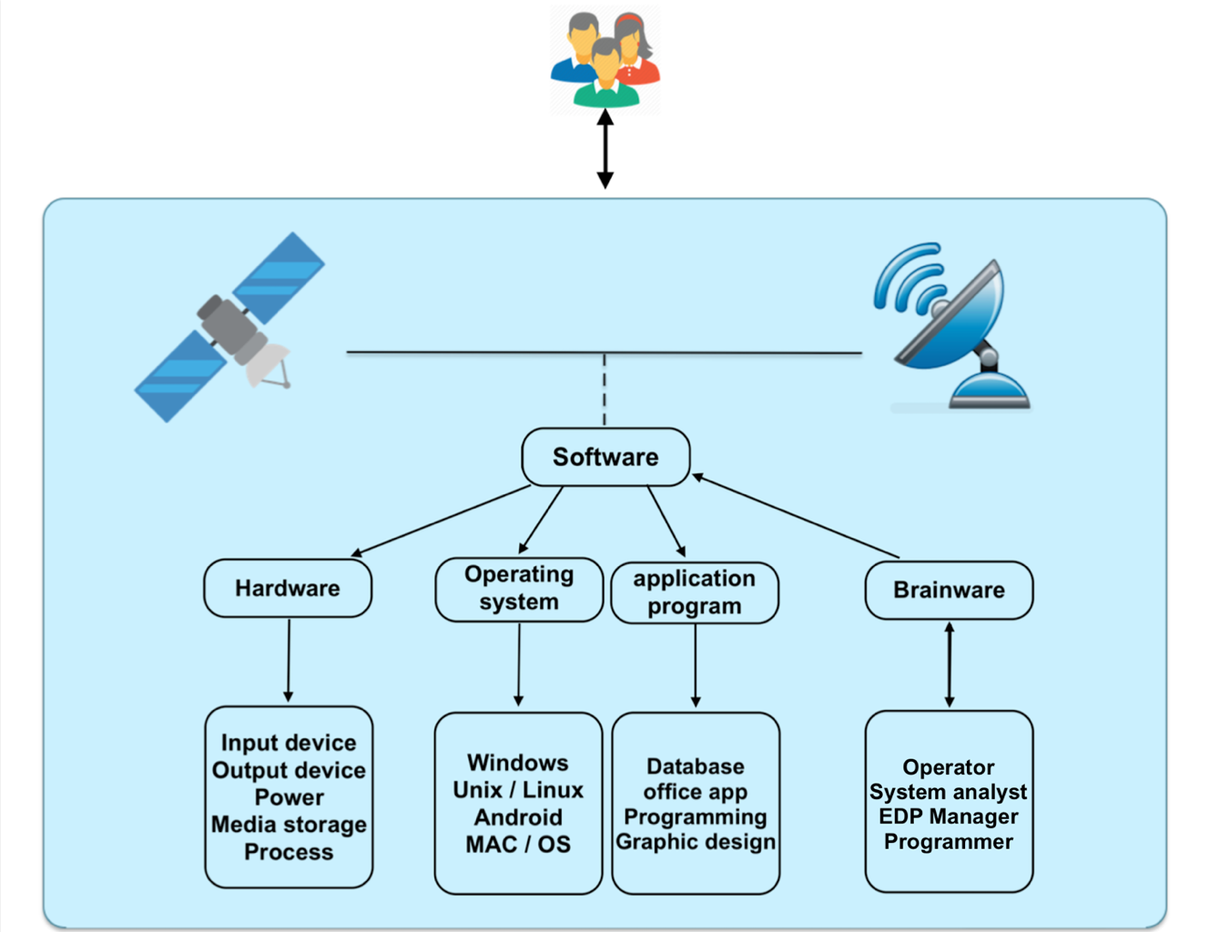

## Subsystem description

🡪 **Hardware:** Hardware of GPS OsmAnd is Display, Monitor, Antenna, Sensors and others.

🡪 **Android:** There are several ways to view maps. For offline use, you need to pre-download your maps.

🡪 **iOS:** As you install OsmAnd iOS application, you'll be able to view and manage offline maps of virtually any country in the world.

🡪 **Database:** OsmAnd (OSM Automated Navigation Directions) is an open source application for map viewing, editing, track recording and touring which utilizes the OpenStreetMap (OSM) database for both online and offline use.

🡪 **Graphic design:** Search for places by address, by type (e.g.: restaurant, hotel, gas station, museum), by geographical coordinates, or along the route